1.

SQL> select distinct FName from Malaysia;

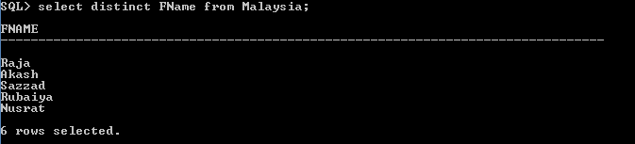

2.

SQL> select SID, FName, Grade From Malaysia where age > 25 and PhoneNumber like

'%8';

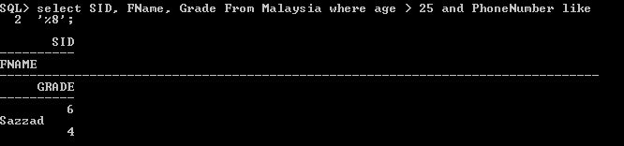

3.

SQL> select FName, Age from Malaysia order by age asc;

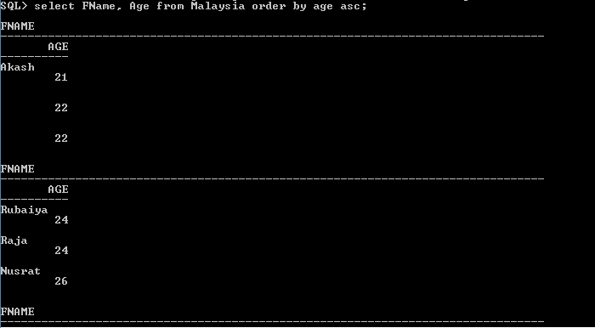

4.

SQL> select FName, Age from Malaysia order by age desc;

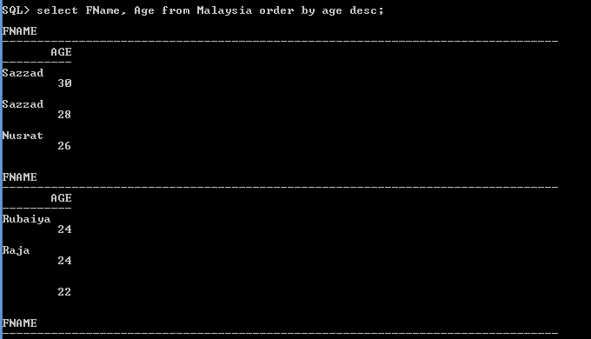

5.

SQL> update Malaysia

2 set FName = null

3 where SID = 1;

2 rows updated.

Here I update the value Ovi to null.

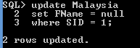

6.

select FName from Malaysia where grade IN(1.25, 2.22, 4.00);

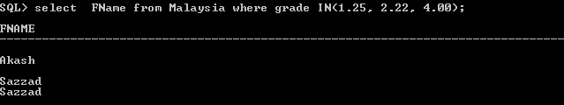

7.

SQL>

select FName from Malaysia where age between 23 and 30;

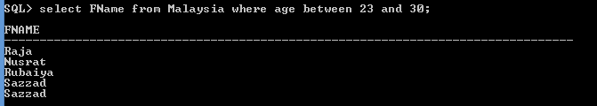

8.

I have learned how to select values from database using condition. In next class I want to learn about join.